Big Mountain Ski Resort: Price recommendation report

* Problem statement
* Data Wrangling
* Exploratory data Analysis
* Model Preprocessing with feature engineering, Algorithms used to build the model with evaluation metric, Winning model and scenario modeling
* Pricing recommendation
* Conclusion
* Future scope of work

**Problem statement:**

Big Mountain ski resort has recently added $1.5mil to its operating budget for a new chairlift, meanwhile there is concern of undercharging for tickets. Can we account for the new chairlift cost and increase revenue by 10% or more over the next year by increasing ticket prices, based on data for competitor pricing of resorts with similar amenities? The data scientist will determine if certain Big Mountain facilities could justify a greater ticket value than what is currently charged, what could be added to the resort to justify an even greater ticket price and bring more profit, and whether certain facilities may not be adding enough to ticket value and thus maintenance should be reduced in those areas, or eliminated entirely.

**Data Wrangling:**

We checked completeness for each observation, if there were null values or any suspicious non-nulls, checked and accounted for any potentially duplicate observations, and established the meaning and significance of columns for which it was unclear. One suspicious possible duplicate observation was Crystal Mountain but we confirmed that there are two distinct resorts in different states sharing the same name. There was an issue with a seemingly mistaken skiable terrain data point but we were able to find better data online to replace it. Certain columns and rows were dropped from the data, like columns of mostly empty and meaningless values. We also dropped the ‘AdultWeekday’ column because we determined ‘AdultWeekend’ price data is more relevant, and has more complete data. All rows with no price data were dropped because they can't help us predict ticket price.

**Exploratory data analysis:**

We engineered features like the number of resorts per capita in a state, and percent of state market share for each resort. The resort-level dataframe shows the resorts' relative share of their states' market, how much relative skiable area, days open, terrain parks, and night skiing area each resort has. Some additional features that we engineered were the ratio of chairs to runs for each resort, and ratio of fast quads to runs. The correlation heatmap is a simple, fast way to visualize relationships between a large number of variables.

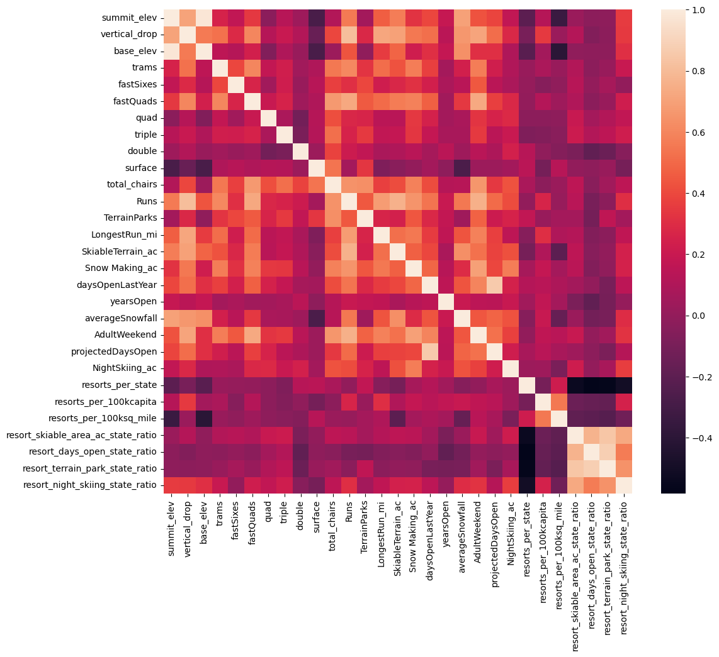

Some features are expectedly correlated eg. summit and base elevation. Vertical drop, fast quads, number of runs, and total chairs are target features for modeling because they correlate most strongly with ticket price.

**Model Preprocessing with feature engineering, Algorithms used to build the model with evaluation metric, Winning model and scenario modeling:**

Testing the performance of a model using just the average price as the predictor yielded an MAE of $19. We then made a linear regression model. Using the R^2 metric on our linear regression shows our model explains over 80% of the variance in the training set data and 70% on the test set, and the MAE for this model is $9. Cross-validation on our linear regression model shows we are getting average test scores of .63 with STD ~.1. We made a random forest model, including preprocessing steps of imputing missing values using medians. The estimated performance from cross-validation is .69 with a STD of ~.07. This shows that the random forest model has greater accuracy and less variability than linear regression model. We use the random forest model for predictions moving forward.

**Pricing recommendation:**

Big Mountain Resort currently charges $81 per ticket. The model suggests that given its facilities, a ticket price of $95.87 could be supported. This increase in ticket price

would bring an addition of revenue equal to 350,000 visitors x 5 tickets per visitor x (suggested price-current price) = $26,022,500, which is ~17x more than the maintenance budget for the new chairlift.

**Conclusion:**

As to the original business problem, Yes, we can account for our newly increased chairlift operating budget, and raise revenue substantially by increasing ticket prices, which is well justified given Big Mountain Resort’s facilities.

**Future scope of work:**

If any changes to facilities would be made to support further price increases, the scenario of adding a run to increase vertical drop by 150' is recommended. We could increase ticket price $1.99, which would bring double the revenue required to maintain the additional chair lift that would be required. As for run closures, it is most likely that closing any would reduce ticket price more than it's worth.